Revision History
Date | Version | Description | Author
<15/11/2017> | <1.0> | Detailed design layout for the ASI software. | <Atakan ATAMERT, Bora Berk AKDENİZ, Orkun DOĞAN, Oğulcan CİNGİLER, Sami MENTEŞ>

TABLE OF CONTENTS
1 Introduction 3
1.1 References 3
1.1.1 Project References 3
2 Software Architecture overview 3
3 Software design description 3
3.1 Player 3
3.1.1 Component interfaces 3
3.1.2 Component design description 4
3.1.3 Workflows and algorithms 4
3.1.4 Software requirements mapping 5
3.2 Game 5
3.2.1 Component interfaces 5
3.2.2 Component design description 6
3.2.3 Workflows and algorithms 6
3.2.4 Software requirements mapping 6
3.3 Engine 6
3.3.1 Component interfaces 6
3.3.2 Component design description 7
3.3.3 Workflows and algorithms 7
3.3.4 Software requirements mapping 7
3.4 Interconnected Server-Databse 7
3.4.1 Component interfaces 7
3.4.2 Component design description 7
3.4.3 Workflows and algorithms 7
3.4.4 Software requirements mapping 7
4 COTS Identification 7

Introduction

This document describes the design of the ASI software system.

References

Project References

# | Document Identifier | Document Title
[SRS] | ASI-SRS-1 | ASI Software Requirements Specifications

Software Architecture overview
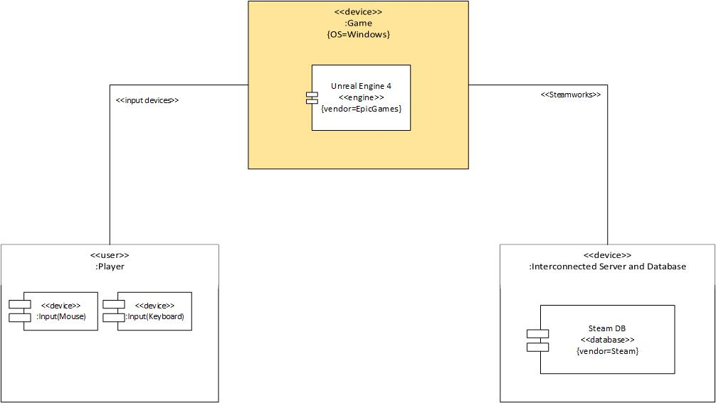

Software design description

Player

Component interfaces
The player will be interfacing with the game by giving it inputs through keyboard and mouse. The player will also receive output from the game through the screen.

The inputs will consist of movement keys (W, A, S, D, E, Q, Spacebar, Left CTRL, Shift, Mouse movement (Up, Down, Left, Right)) and action keys (R, F, LMB, RMB, G, MMB, 1, 2, TAB). The output will be shown on the screen for the player to see.

Component design description
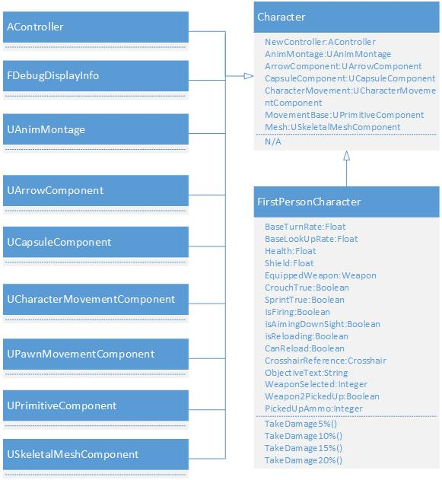

Workflows and algorithms
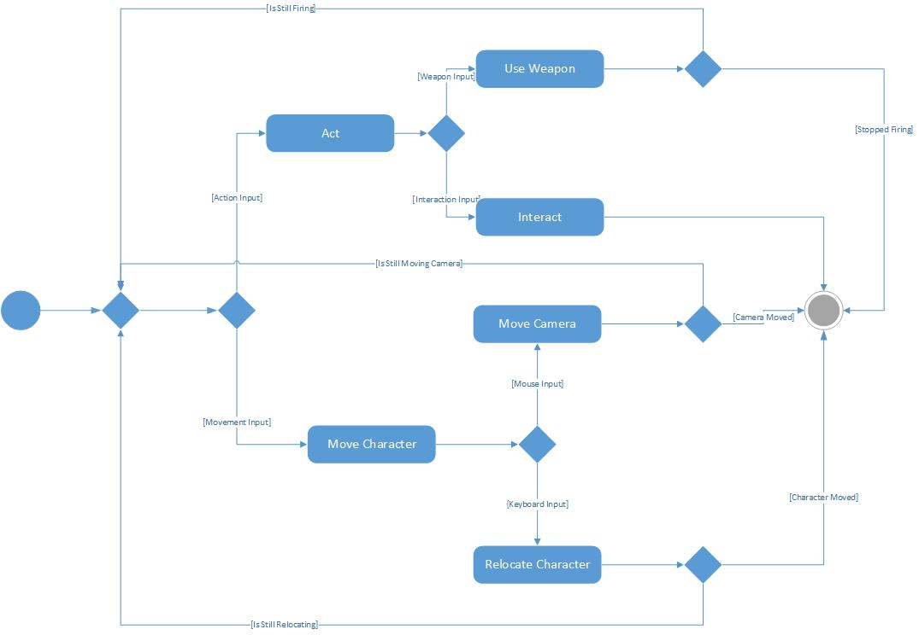

Algorithm description not possible. The algorithms are described by internal engine methods.

Software requirements mapping
- SRS-ASI-003.1

Game

Component interfaces
The player will be interfacing with the game by making selections through the main menu. The player will also receive output from the game through the screen. The player will interact with its character while the game is running through mouse and keyboard inputs.

The inputs will consist of three main menu components (Play Game, Options and Quit) and four other sub-components for the “Options” component (1920x1080, 1280x720, 640x480 and Main Menu). The output will be shown on the screen for the player to see.

Component design description
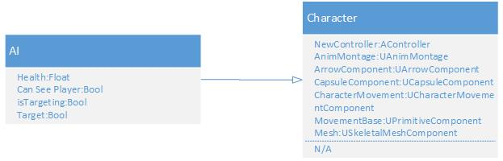

Workflows and algorithms
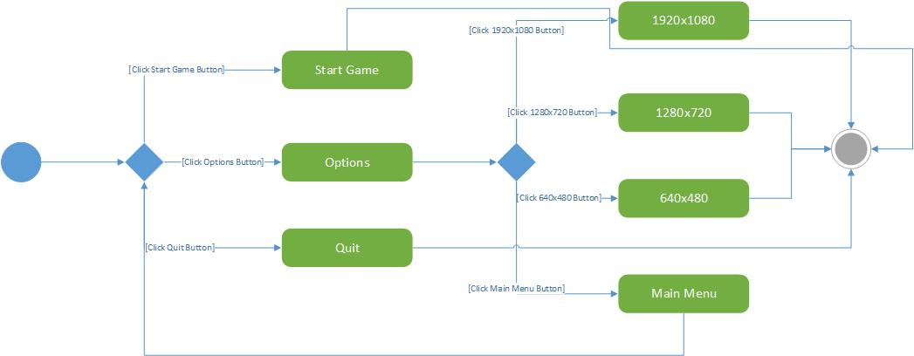
- Start Game button has the method where it removes the current HUD, replacing it with FPSHUD and possessing the pawn for the player, starting the game.
- Options button changes the visibility of the buttons placed on the Main Menu HUD, it brings forth the resolution option buttons and back to main menu button.
- Quit Button simply terminates the software.
- The option buttons shown on the screen change the resolution of the game by scaling the current screen resolution according to the chosen option.
- Main Menu button under the Options menu, brings forth the Main Menu buttons back on the screen by changing the visibility of the buttons placed on the Main Menu HUD.

Software requirements mapping
- SRS-ASI-001.1
- SRS-ASI-002.1
- SRS-ASI-004.1
- SRS-ASI-008.1

Engine

Component interfaces
Internal interfaces.

Component design description
Internal classes are used which are not available to end-users.

Workflows and algorithms
Internal engine algorithms are used.

Software requirements mapping
- SRS-ASI-005.1

Interconnected Server-Database

Component interfaces
Steam server and databases will be connected to our game via an internet connection via the Steamworks API. Certain updatable data will be sent to the servers hence the databases, so they will also be updated on different instances of the game on different devices.

Component design description
Internal components are used for Steam server and databases.

Workflows and algorithms
Internal algorithms and workflows are used.

Software requirements mapping
- SRS-ASI-006.1
- SRS-ASI-007.1

COTS Identification
COTS (commercial of the shelf) libraries used in ASI are the following:
- Steamworks SDK, v1.41,https://partner.steamgames.com/downloads/steamworks_sdk_141.zip, Steamworks SDK License

